Writing Test Cases
This course is a standard data structures course. However, we also include a strand on testing the code we write.
With complex software systems, no one can ever test all of the functionality in all of the conditions that your customers will see. Start with this as a fact. You will never test enough! That knowledge should cause a certain amount of discomfort. Good, for you have taken the first step at creating a great test plan.
[Software] Testing is the process of executing a program with the intent of finding errors.
There is big difference between testing to show that something works versus testing to show that something fails.
The following are some general guidelines for creating test cases:
- For each input case, know exactly what you expect to see in the output.

- Every requirement should be tested at and beyond its boundary conditions (for example: high and low limits) as well as mid points.
- Black box testing, meaning that you should write some test cases without knowing what is inside the box.

- White box testing, meaning that some tests should include testing based on knowing what is inside. For example, if you know that an algorithm for generating 10,000 different outputs is done with a formula, you will not need to test all 10,000 outputs. However if you know that it is done with a table with some break points in the table where different algorithms are used at each break point, you will want to include this in your testing.

- Showing that the software does what it's supposed to do is only half the battle. The other half is determining if the software is doing what it is not supposed to do.
You will be submitting your programs to CodePost. If your code passes all the CodePost tests, you get full credit. Congratulations! If not, you may change the code and resubmit.
Figuring out the CodePost error messages is not always easy. The teachers have tried to clearly label what we are allowed to label. We wanted to list the test cases for you. Unfortunately, the only way we could find to list the testcases also generates a FAILED message, as shown in this screen shot for Modes:
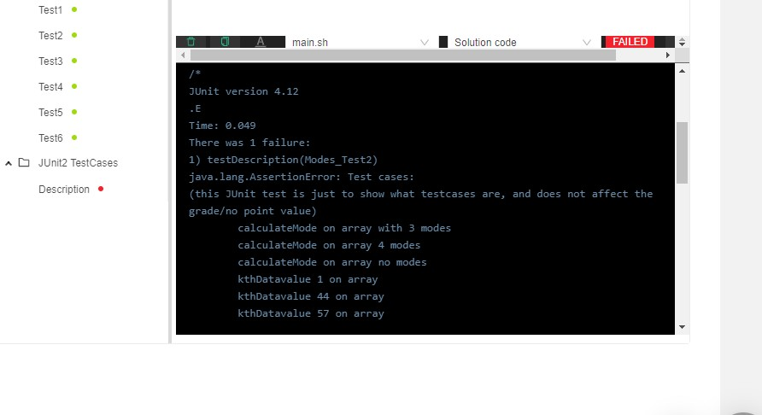
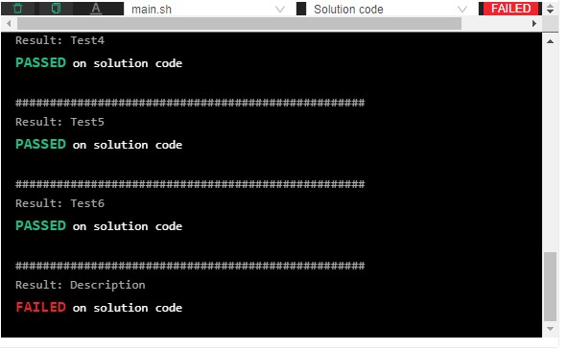
Therefore, this submission for Modes earns full credit.

